**Practice Simulation of Pushbutton Control for LED and Relay on ESP32**

*Andreika Luna Alghivari*

*Fakultas Vokasi, Universitas Brawijaya*

*Email: andreikaluna@student.ub.ac.id*

**Abstract**

This study focuses on the simulation practice of integrating a relay, button, and LED with an ESP32 microcontroller using the Wokwi platform and PlatformIO in Visual Studio Code. The simulation demonstrates how to control a relay and LED through button inputs, showcasing the ESP32's GPIO capabilities and its application in automation systems. By leveraging Wokwi's virtual environment, this project eliminates the need for physical hardware, providing a cost-effective and accessible way to learn about microcontroller-based control systems. The successful implementation highlights its potential for real-world applications such as smart home automation and device control.

*Keywords: GPIO, ESP32, Button, LED, Relay, Wokwi, Visual Studio Code, PlatformIO, Arduino.*

**1. Introduction**

* 1. **Background**

The ESP32 microcontroller is widely used in IoT and embedded systems due to its robust features, including Wi-Fi connectivity and versatile GPIO pins. Relays are essential for controlling high-power devices using low-power signals from microcontrollers, while LEDs provide visual feedback, and buttons serve as user input devices. Simulating these components on the Wokwi platform allows developers to design and test circuits virtually without physical hardware. Using PlatformIO in Visual Studio Code provides an efficient development environment with advanced features like debugging and code management. This combination of tools offers an ideal setup for learning and prototyping IoT-based control systems.

* 1. **Objective**

1. To demonstrate the integration of a relay, button, and LED with an ESP32 microcontroller using the Wokwi simulator.
2. To program the ESP32 through PlatformIO in Visual Studio Code for controlling the relay and LED based on button inputs.

**2. Methodology**

**2.1 Tools & Materials**

LED, Relay module, Pushbutton, Wokwi, ESP32, Arduino IDE, and Visual Studio Code.

**2.2 Implementation Steps**

1. Create a new project in wokwi and select ESP32
2. Add the relay, pushbutton, and LED. Connect the pushbutton to GPIO19 using an internal pull-up configuration, the LED to GPIO18, and the relay to GPIO23.
3. Enter the sketch.ino code according to the module
4. Create a new project in platform.io
5. Enter the C++ code in src/main.cpp
6. Edit the platform.ini file according to the module
7. Create a diagram.json file and copy and paste the code from diagram.json into wokwi
8. Create a wokwi.toml file and fill in the firmware code and elf from the copy relative path after compiling the main.cpp file
9. Request license to wokwi.com
10. Start Simulator

**3. Results and Discussion**

**3.1 Experimental Results**

The simulation of integrating a relay, button, and LED with the ESP32 using the Wokwi platform and PlatformIO in Visual Studio Code was successfully executed. The system effectively controlled the relay and LED based on button inputs, demonstrating the ESP32's capabilities in automation. This virtual setup provided an accessible way to learn microcontroller-based control systems without physical hardware. The success of this project highlights its potential for real-world applications, such as smart home automation and IoT solutions.

1. Diagram.json

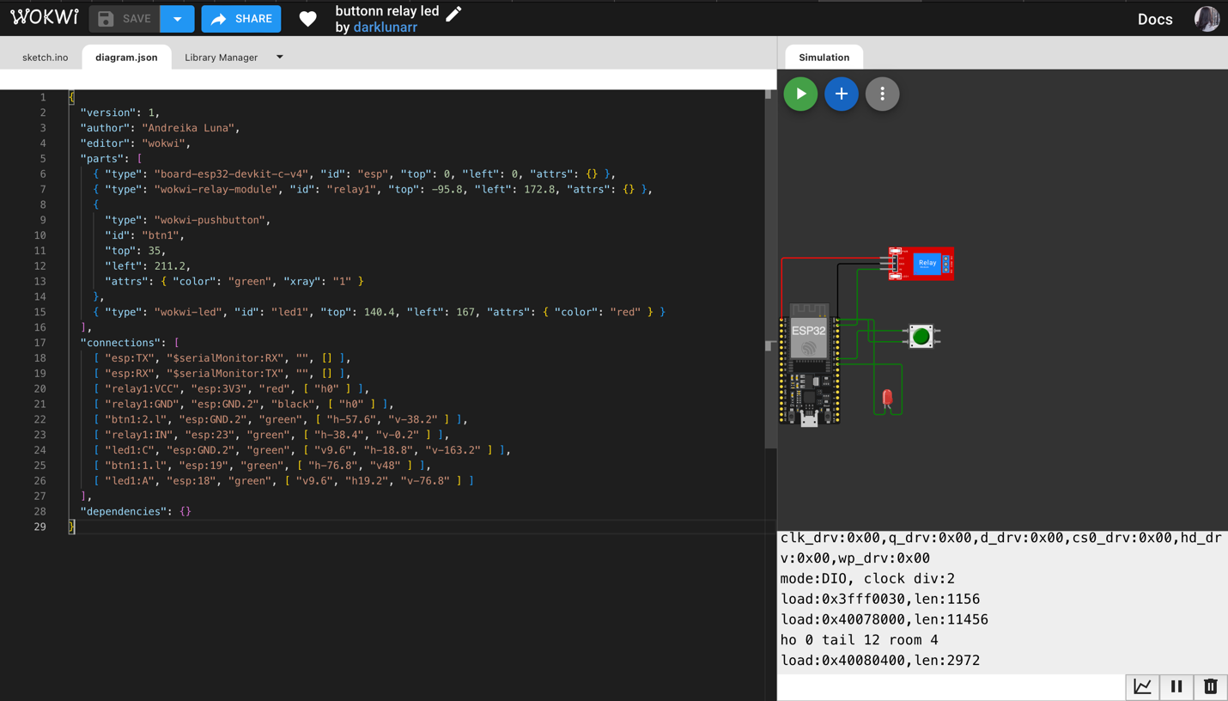

1. Main.cpp

1. Results

